EXPERIMENT 6

Aim:
To visualize and analyze the distribution and relationships of variables in the tips dataset using different Seaborn plots.
Procedure:
- Imported necessary libraries: seaborn, pandas, numpy, and matplotlib.
- Loaded the built-in Seaborn dataset tips for analysis.
- Used displot and boxplot to visualize the distribution and spread of total_bill and tip.
- Displayed categorical data distributions using countplot and pie chart for variables like day and sex.
- Explored relationships between numerical variables using jointplot (scatter, regression, and hex) and pairplot.
- Generated a heatmap to study correlations between numerical features.

import seaborn as sns import pandas as pd import numpy as np import matplotlib.pyplot as plt
%matplotlib inline sns.set_theme(style="whitegrid", palette="pastel") tips = sns.load_dataset('tips')
sns.displot(tips.total_bill, kde=True) plt.show()
sns.displot(tips.total_bill, kde=False) plt.show()
sns.boxplot(x=tips.total_bill) plt.show()
sns.boxplot(x=tips.tip) plt.show()
sns.countplot(x="day", data=tips) plt.show()
sns.countplot(x="sex", data=tips) plt.show()
sns.jointplot(x="tip", y="total_bill", data=tips) sns.jointplot(x="tip", y="total_bill", data=tips, kind="reg") sns.jointplot(x="tip", y="total_bill", data=tips, kind="hex")
sns.pairplot(tips) plt.show()
sns.pairplot(tips, hue="time") plt.show()
sns.pairplot(tips, hue="day") plt.show()
sns.heatmap(tips.corr(numeric_only=True), annot=True, cmap="coolwarm") plt.show()
tips.sex.value_counts().plot(kind="pie", autopct="%1.1f%%", figsize=(5,5), colors=sns.color_palette("pastel")) plt.ylabel("") plt.show()
tips.sex.value_counts().plot(kind="bar", color=sns.color_palette("pastel")) plt.show()
sns.countplot(x="day", data=tips[tips.time=="Dinner"]) plt.show()
In [ ]:
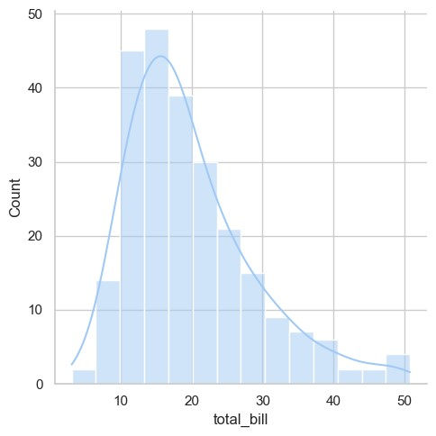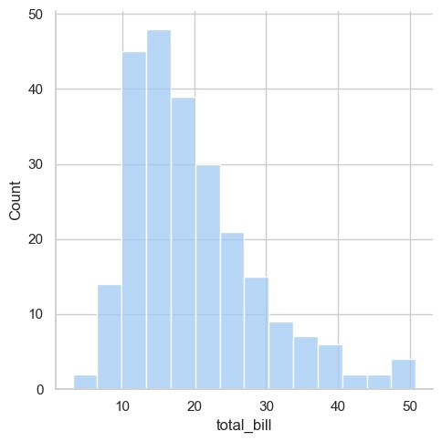
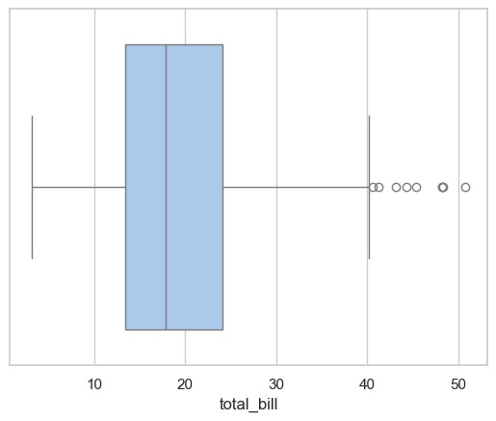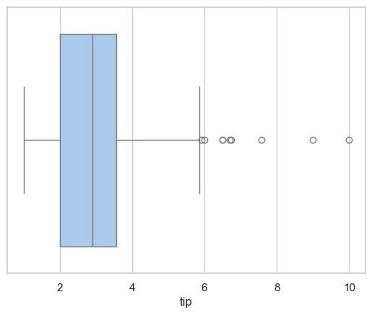
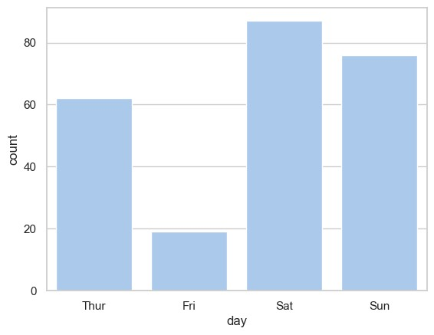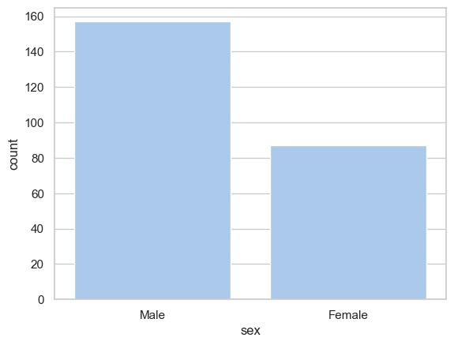
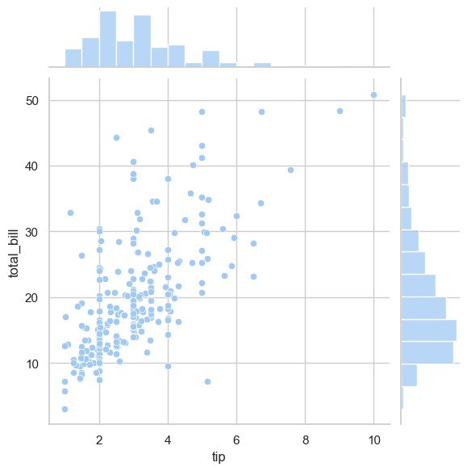
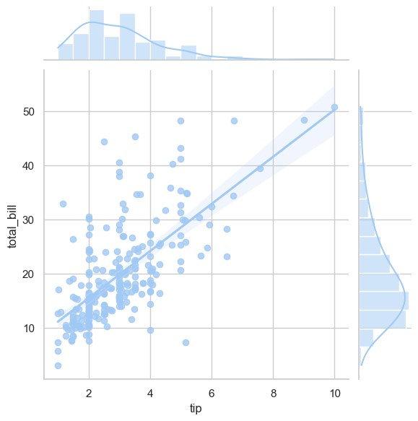
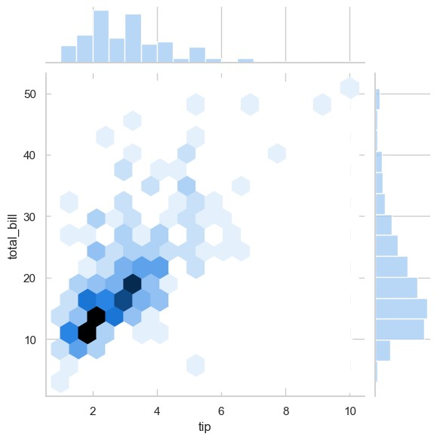
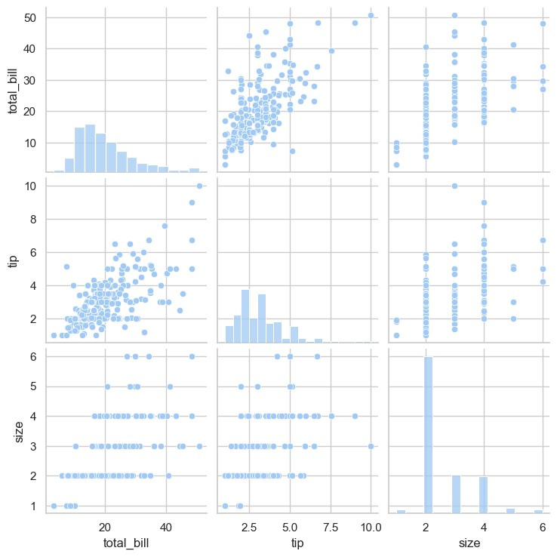
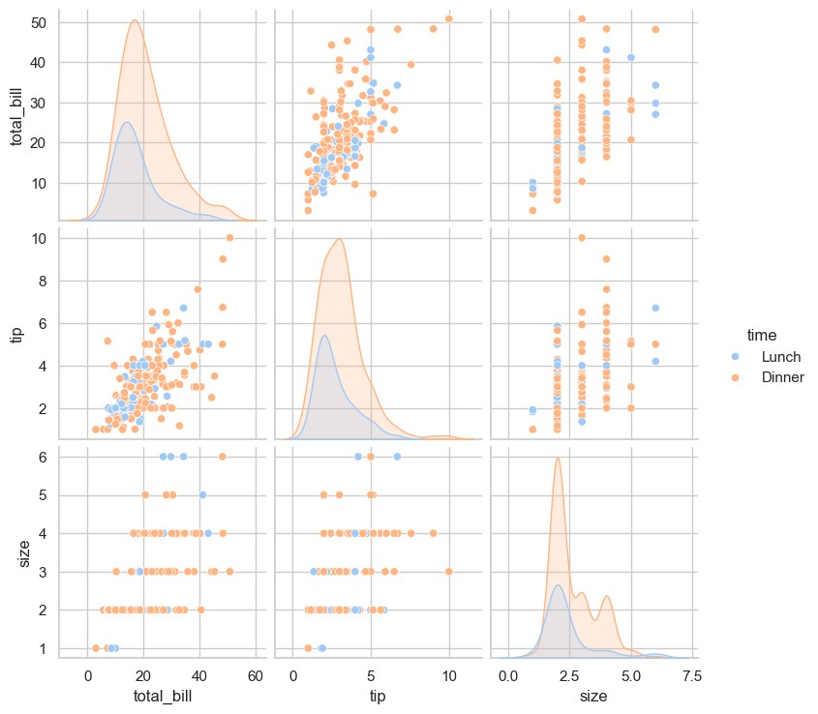
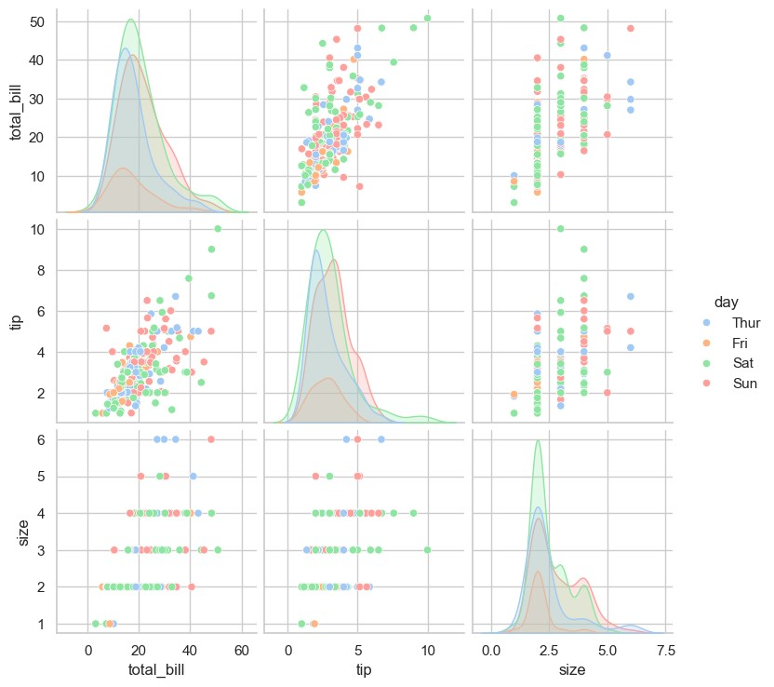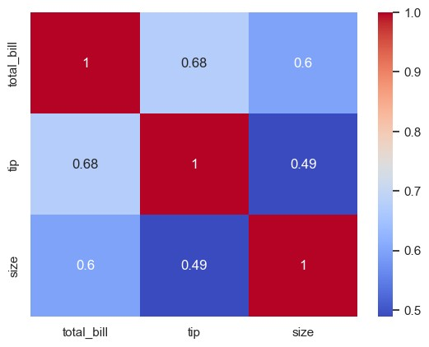
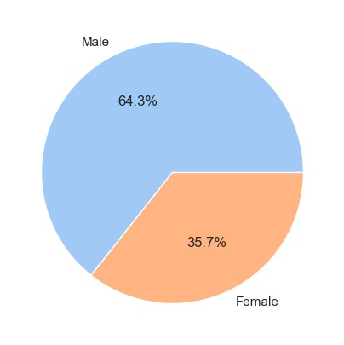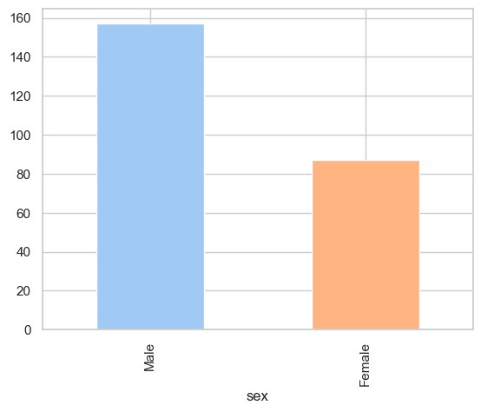
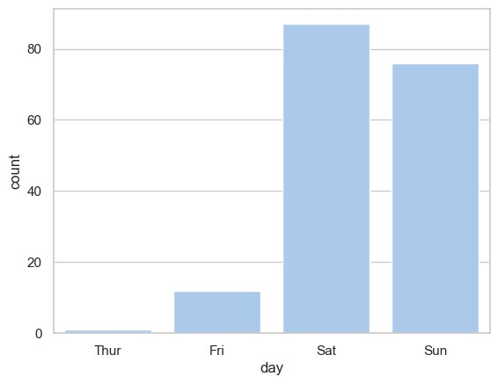

Result:
The tips dataset was successfully visualized using multiple Seaborn plots.
These visualizations revealed clear insights into data distribution, relationships, and category comparisons.

